# Admin

## 用戶管理

當具有管理員權限的帳號登錄通過後，DocTracker主頁將顯示如下的用戶帳戶摘要

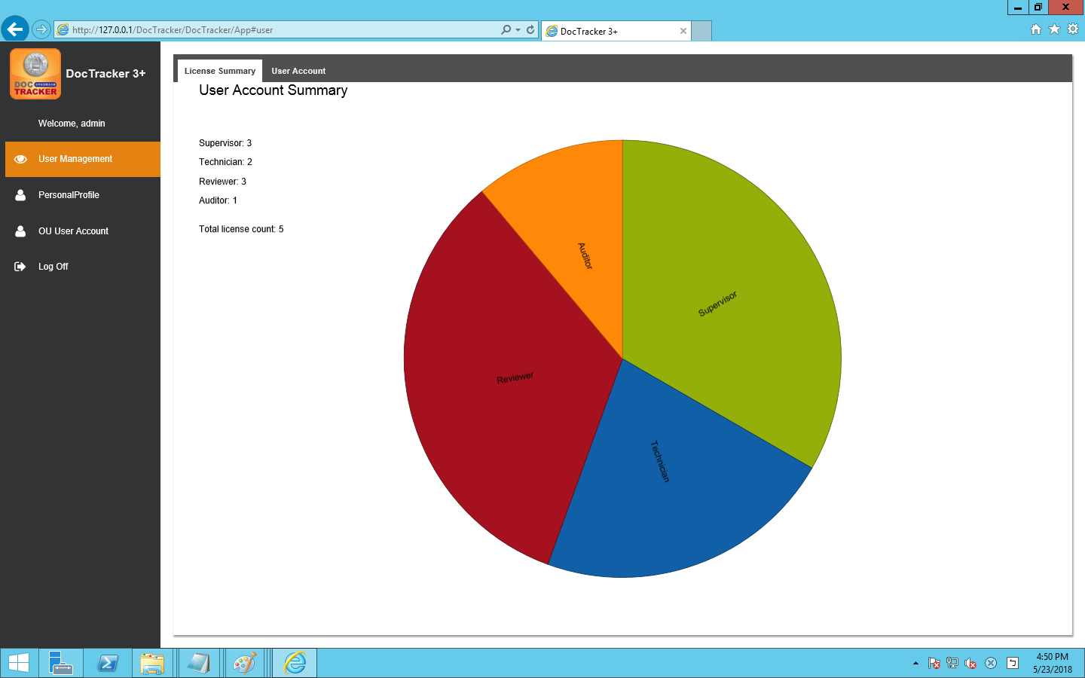

### 1.1 新增使用者

在設置和開始使用DocTracker之前, 需要為不同的角色創建使用者帳號：Admin角色可創建(Supervisor, Technician)角色的帳號；Supervisor角色可創建(Auditor,Reviewer)角色的帳號。 在左方選單選擇[管理用戶]之後，在右方選擇[用戶帳號]頁籤。按下按鈕後，下方視窗彈出：

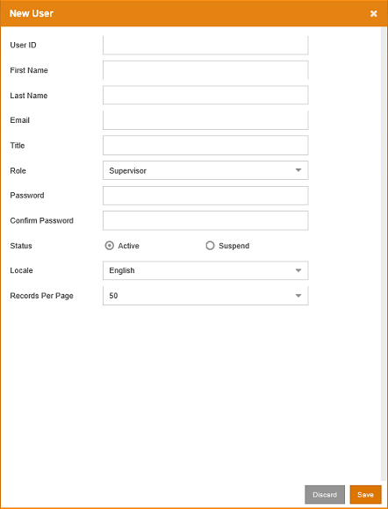

頁面上各個欄位及按鈕的功能詳列如下：

| 欄位 / 按鈕 | 說明 / 功能 |
| --- | --- |
| 用戶帳號 | 使用者唯一的登錄ID。 |
| 用戶名 | 用戶的名字。 |
| 用戶姓 | 用戶的姓氏 |
| 電子郵件 | 用戶的電子郵件地址 |
| 職稱 | 用戶的職稱。可留空。 |
| 角色 | Technician角色的帳號有權限去設定系統。Supervisor角色的帳號有權限去建立 Reviewer 和 Auditor。 |
| 密碼 | 使用者的登入密碼 |
| 確定密碼 | 重新輸入使用者的登入密碼 |
| 狀態 | 使用者的狀態。「Active」讓使用者能夠登錄到系統。「Suspend」禁止 使用者訪問系統。 |
| 語言 | 使用者介面呈現的語言。可設定為「English」（英文）、「Simplified Chinese」（簡體中文）、「Traditional Chinese」（繁體中文）。 |
| 每頁紀錄 | 每頁顯示的記錄數。 數值的範圍從10到60。 |
|  | 按此按鈕離開此頁面而不添加使用者帳號。 |
|  | 按下此按鈕可透過已輸入的使用者資訊來創建使用者帳號。 |

### 1.2 更新使用者資訊

To update the user properties, select the user and click the  button or double click the user to bring up the following update user screen:

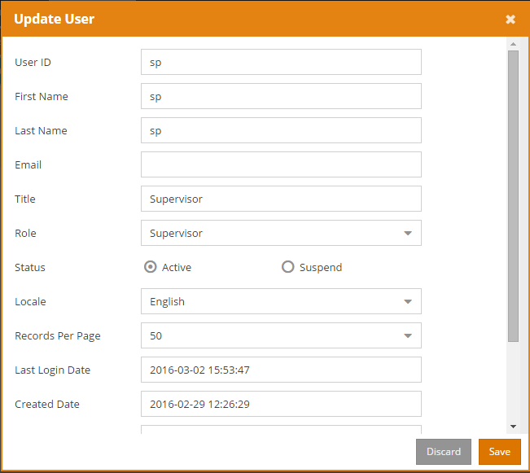

Once the modification is made, click the  button to save changes. Click the  button to exit the screen without saving.

### 1.3 刪除使用者帳號

如果要進行使用者帳號刪除, 勾選要刪除的使用者帳號後按下 鈕。畫面跳出如下的確認刪除提示訊息。

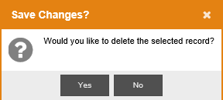

按一下  後刪除使用者，又或按一下  取消刪除動作。

### 1.4 重置密碼

To reset password of a specific user, select the user and click the  button to bring up the following Reset User Password screen:

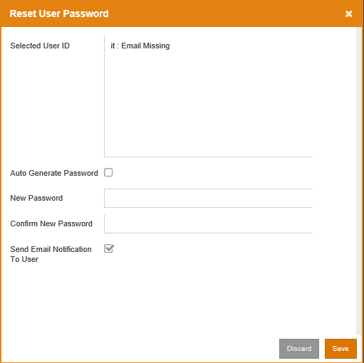

按一下  鈕重置。按一下  鈕離開畫面而不去重置密碼。

The following table describes the fields in the Reset User Password screen:

|  |  |
| --- | --- |
| 欄位 | 說明 |
| 已選用戶帳號 | 顯示所選的用戶帳號，以及該用戶是否有設定電子郵件地址 |
| 自動產生密碼 | 自動生成密碼，並通過電子郵件發送給此用戶。 |
| 新密碼 | 為此用戶定製一個密碼。 |
| 確認新密碼 | 再一次輸入剛才定製的密碼。 |
| 電子郵件通知用戶 | 在為該用戶定製過密碼後，將密碼透過電郵向用戶發放。 |

### 1.5 檢視部門 (except MFP)

查看訪問映射權限中的用戶映射, 或者查看AD OU映射中的AD / OU權限, 按下 按鈕去瀏覽群組和群組底下的使用者.

## 使用者 個人資料

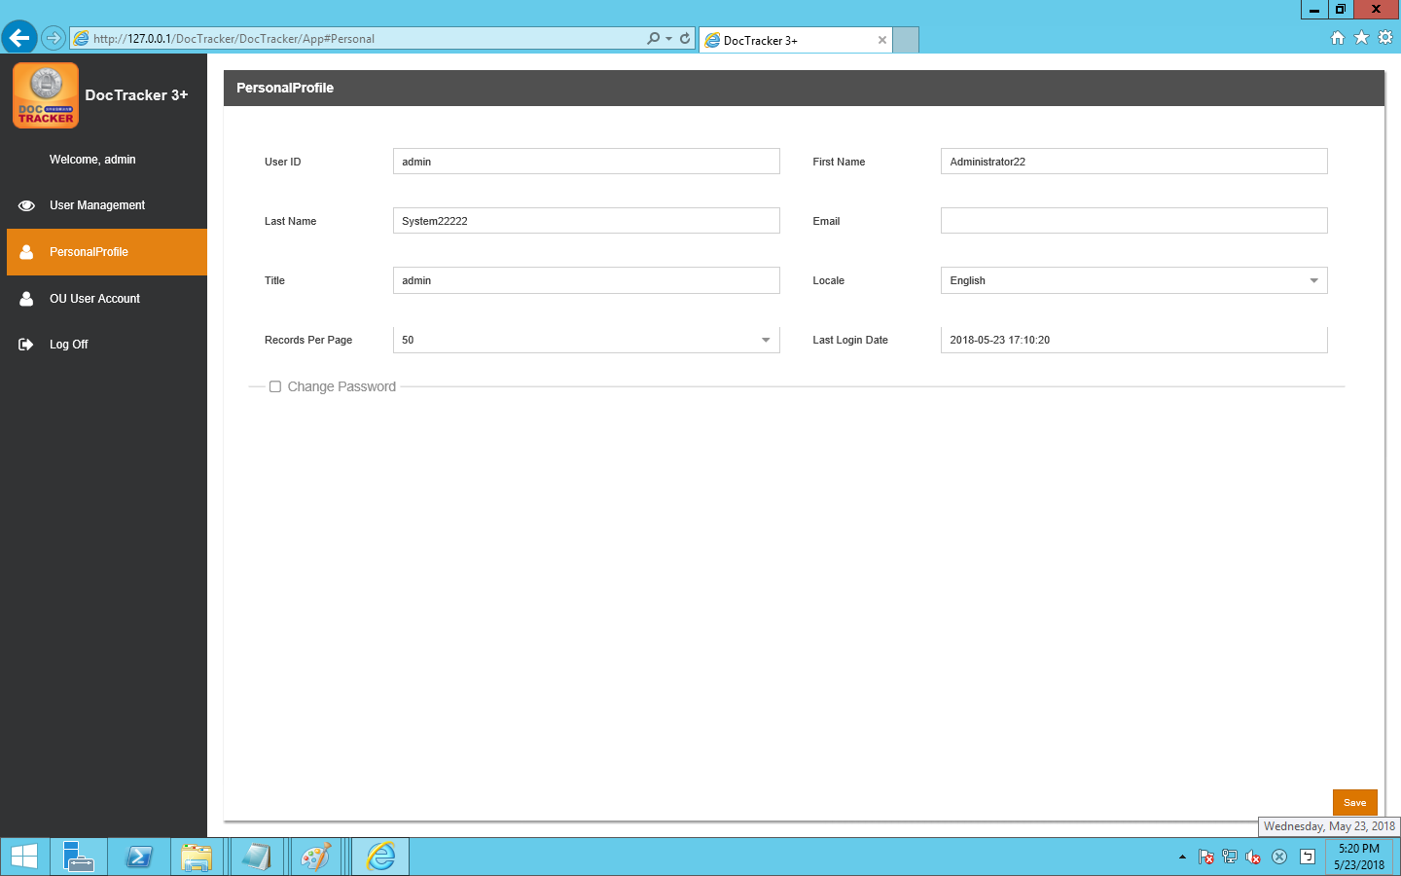

It shows user information about [User ID] [First Name] [Last Name] [Email] [Title] [Locale][Records Per Page][Last Login Date], language can be adjusted by [Locale].

In addition to the [User ID] can not be changed, other information can be changed

Press after change and a following message appears

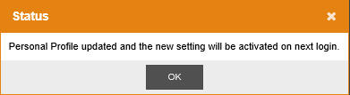

The new setting will take effect after the next login.

## OU 使用者帳號

This page is used to synchronize the Account from Active Directory(AD) Server to Doctracker System.

### AD 伺服器

There are few things that should be noticed:

🡪 AD Server must be prepared.

🡪 OU is created(OU Name does not matter).

🡪 Inside the OU,4 Group must be added and the name must be specified(Auditor, Reviewer, SP, Tech)**.** And the groups contain the users.

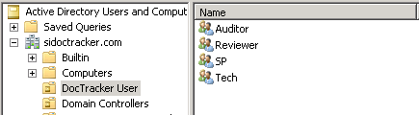

🡪 Do NOT tick 

When create or modify the user, it will block the login function from

DocTracker 伺服器。

Before synchronizing account, configuration must be done on DocTracker Server.

### Sync Account Config

To configure information of server, press button and following screen show:

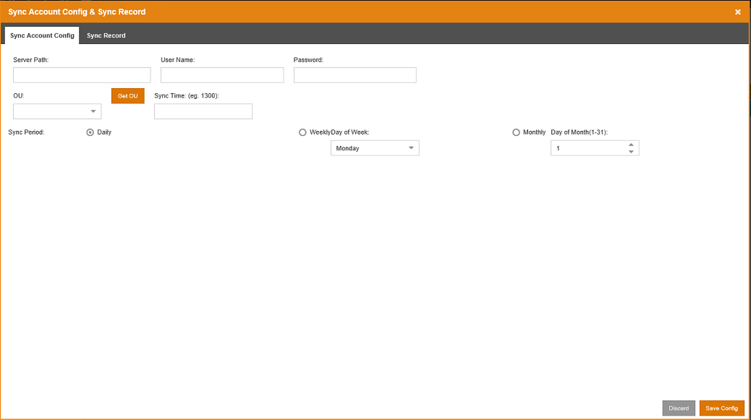

以下為每個名詞的描述：

|  |  |
| --- | --- |
| 欄位 / 按鈕 | 說明 / 功能 |
| 伺服器路徑 | AD 伺服器的IP 位址 |
| 使用者名稱 | AD 伺服器的使用者名稱。 |
| 密碼 | AD 伺服器的密碼。 |
| OU | 從AD伺服器中選擇的OU |
|  | 從AD伺服器獲取OU |
| 同步時間 | 在一天內會與AD伺服器同步的時間 |
| 同步週期 | 有三種同步週期：每日、每週或每月。 |

按一下  鈕儲存變更。按一下  鈕離開畫面而不去儲存變更。

在儲存並離開設定頁面後, 使用者可以按一下  去進行同步而無需等待設置時間

### 同步紀錄

同步紀錄會在同步過程發生時保存。

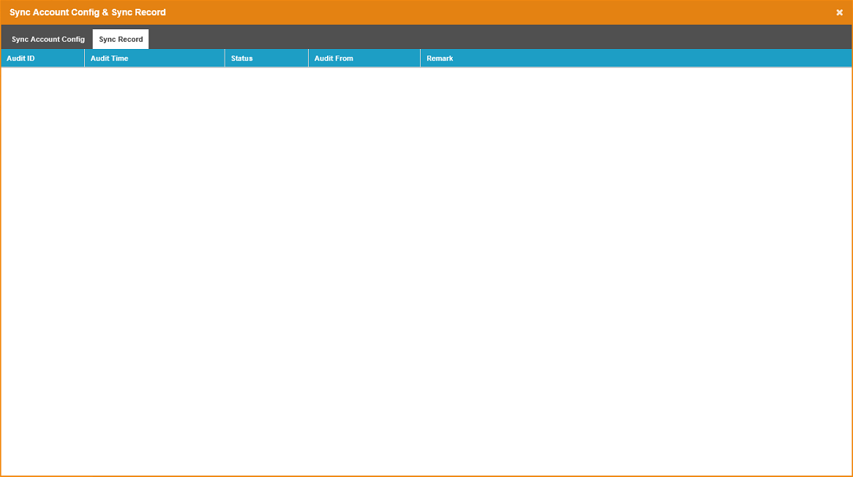

「提示」欄位的定義：

|  |  |
| --- | --- |
| 提示 | 說明 |
| 在OU中所有的帳號 | The total users of the 4 groups (Auditor, Reviewer, SP, Tech) on AD Server. |
| Total Existing Account | The total number of OU users on current DocTracker Server. |
| Created | The numbers of OU users are synchronized into DocTracker Server. |
| Updated | The number of existing OU users have updated on the DocTracker Server. |
| Bypassed | OU User(s) is/are conflicted with the local user on DocTracker Server. These users will skip the synchronization. |
| Deleted | The OU Users which are no longer existed on AD Server. These Users will delete from the DocTracker Server. |

# Technician

## OCR Station Management

To define OCR server, click OCR Station Management on the navigation bar, and the following screen will show. At the OCR Station Setting tab, Technician can define OCR Station ID, IP address, Port, and interval time, etc。

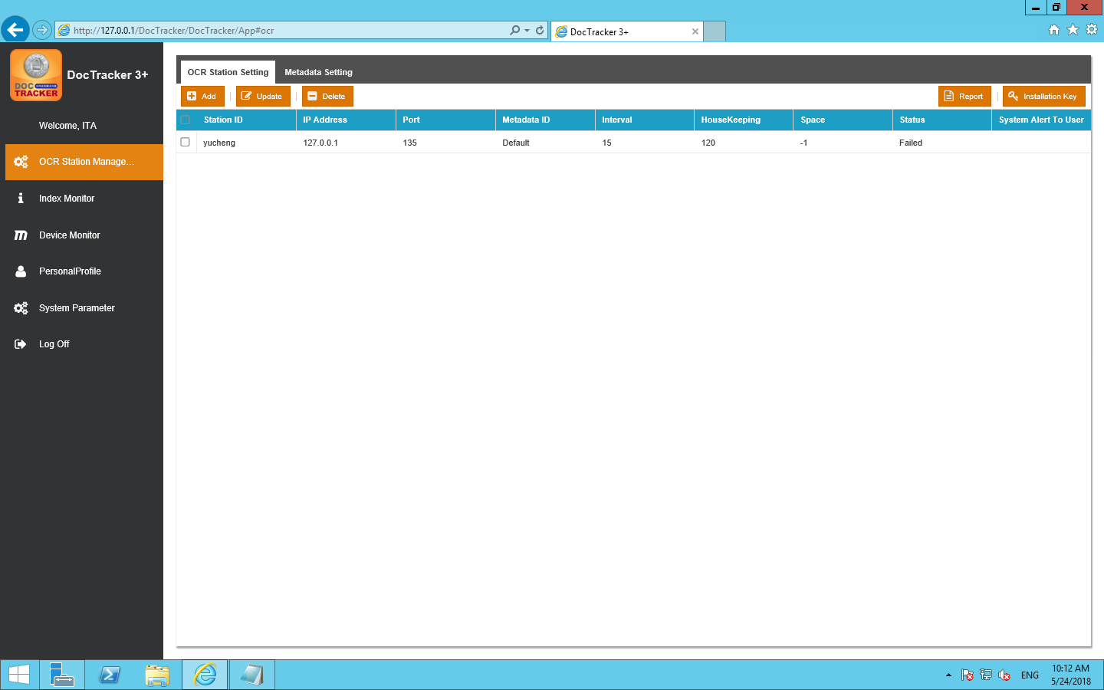

The functions of each field are listed below:

|  |  |
| --- | --- |
| 欄位 / 按鈕 | 說明 / 功能 |
| Station ID | OCR server unique name |
| IP 位址 | OCR 伺服器的IP 位址 |
| Port | OCR server platform’s connection port |
| Metadata ID | Metadata to be used in the OCR server |
| Interval | The interval time (in minute) to monitor the specific folder for OCR server. |
| HouseKeeping | The time period (in month) to keep the information in the OCR server |
| 可用空間 | Available space (in GB) in OCR server |
| 狀態 | The connection status between the DocTracker server and the OCR server |
| System Alert to User | If OCR server is disconnected, specified DocTracker user will receive an email notification |

### 1.1.1 Add OCR Station

To add a new OCR station, click the  button and the following screen will pop up:

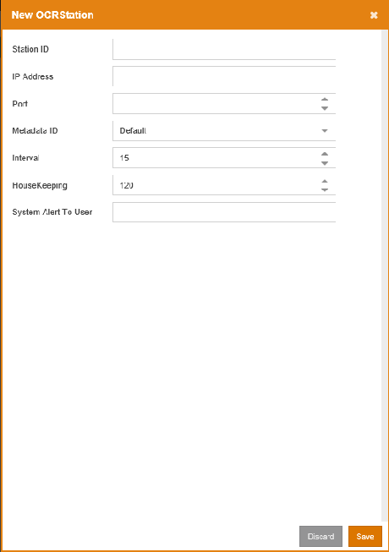c

### 1.1.2 Update OCR Station

To update any setting of an OCR server, select the OCR station and click the button or double click the OCR station to bring up the following update OCR station screen:

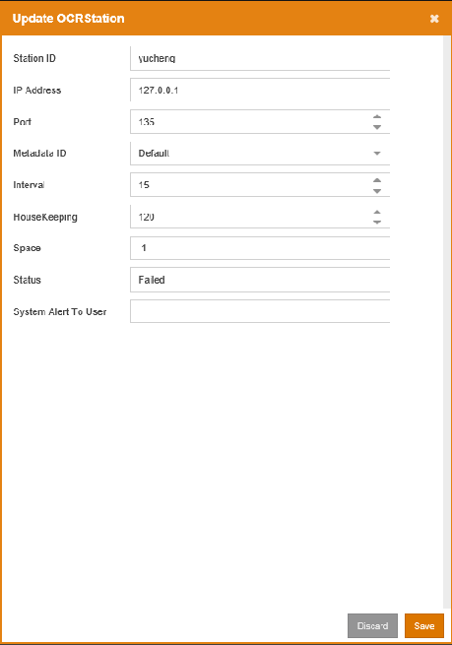

Once the modification is made, click the  button to save the changes. Click the  button to exit the screen without saving.

### 1.1.3 Delete OCR Station

To delete an OCR server, select the OCR server and click the  button. A confirmation message will prompt the user to confirm the deletion of the OCR server as below.

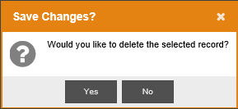

Click the  button to delete the OCR server or click the  button to cancel the deletion.

### 1.1.4 Export OCR Station Info

To export OCR station connection status and space alert report, click the  button, to generate a report in excel.

### 1.1.5 產生安裝軟體的認證

儲存好OCR站設置後，按一下按鈕，用於生成安裝密鑰，安裝OCR服務器時需要該密鑰。If you change the OCR sever setting without generating and applying a new installation key, the connection between the DocTracker server and the OCR server may be affected.

## 索引監視器

The Index Monitor displays the indexing status. DocTracker is able to search documents’ content. If searching content is not functioning properly, click the  button to re-index all records. If there are some failed records which were unable to index, click the  button to re-index the failed records

## Device Monitor

The Device Monitor displays the number of printed documents, the number of copied documents, the number of scanned documents, and the number of faxed documents.

## 使用者個人資料

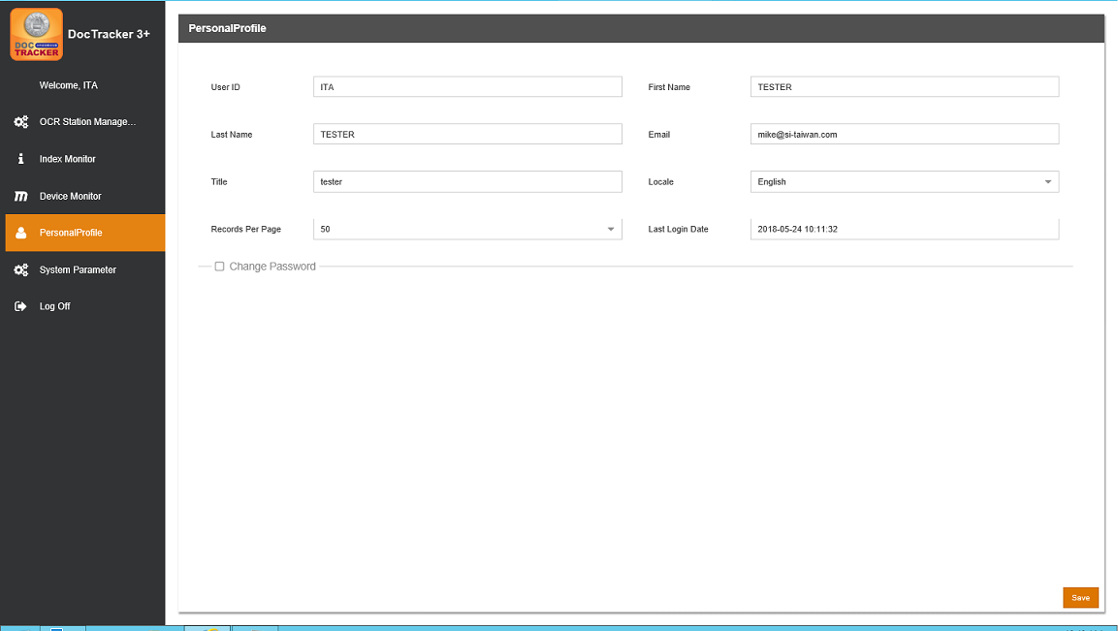

It shows user information about [User ID] [First Name] [Last Name] [Email] [Title] [Locale][Records Per Page][Last Login Date], language can be adjusted by [Locale].

In addition to the [User ID] can not be changed, other information can be changed

Press after change and a following message appears

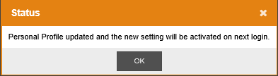

It means new settings will take effect after the next login

## 系統參數

Once login, DocTracker main page will show System Parameter as below, and the technician user can define system setting, SMTP server setting, and email notification setting, etc.

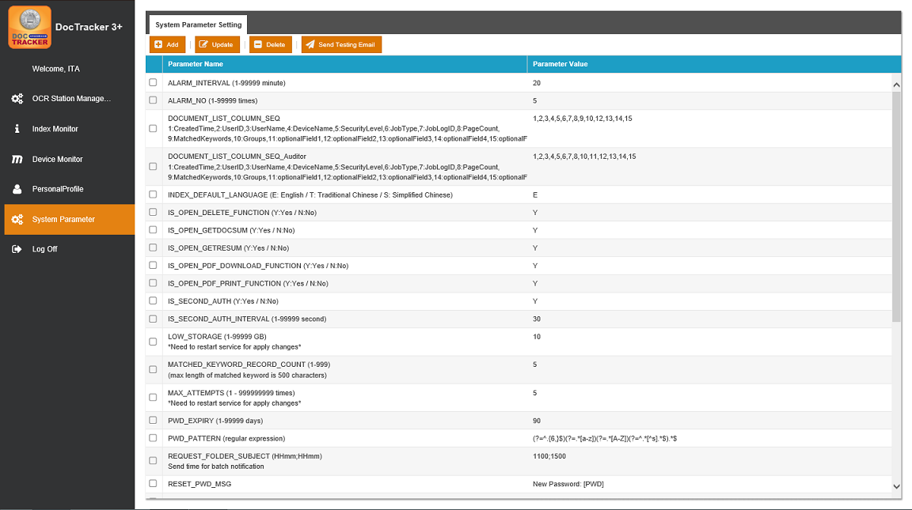

The functions of each System Default Parameter are listed below

|  |  |
| --- | --- |
| Default Parameter Name | 說明 / 功能 |
| ALARM_INTERVAL | When OCR Server is disconnected, the time interval (in min) that DocTracker sends email alert. |
| ALARM_NO | When OCR Server is disconnected, the number of time that DocTracker sends email alert. |
| INDEX_DEFAULT_LANGUAGE | The default language for the index login page. Set value E for English / T for Traditional Chinese and S for Simplified Chinese. |
| IS_OPEN_DELETE_FUNCTION | Define turn on or turn off the delete document function for the reviewer. Set value Y for Yes and N for No. |
| IS_OPEN_PDF_DOWNLOAD_FUNCTION | Define turn on or turn off the download document function. Set value Y for Yes and N for No. |
| IS_OPEN_PDF_PRINT_FUNCTION | Define turn on or turn off the print document function. Set value Y for Yes and N for No. |
| IS_SECOND_AUTH | Determine whether a second user is required to login when a user views a document. Set the value to Y to apply. |
| IS_SECOND_AUTH_INTERVAL | Set the time interval (in sec) allowing the authentication of the second user to keep in the section. |
| LOW_STORAGE  (*Need to restart the service in order to apply any changes) | Set the storage size (in GB) for the system to send an email notification when the storage size of the DocTracker server is running low. |
| MATCHED_KEYWORD_RECORD_COUNT | Set the number of sensitive keyword that the system able to count in a single document. |
| MAX_ATTEMPTS  (*Need to restart the service in order to apply any changes) | Set the number of time a user is able to attempt to login before the system lock the user out. |
| PWD_EXPIRY | The number of day when the password will be expired. Default is 90 days. |
| PWD_PATTERN | Define password complexity. Natural Language Express should be used. |
| REQUEST_FOLDER_SUBJECT | Set the time which an email notification email will be sent by batch mode when a sensitive keyword triggered |
| RESET_PWD_MSG | Reset password email content. |
| RESET_PWD_SUBJECT | Reset password email subject. |
| SEARCH_ENGINE_PATH | Search engine location |
| SEND_LINK_MSG | Document notification email content. |
| SEND_LINK_MSG_NO | The number of document in a single email |
| SEND_LINK_SUBJECT | Document notification email subject |
| SERVER_PATH | DocTracker server IP address |
| SMTP_HOST | SMTP server name or address |
| SMTP_IS_SSL | If SMTP connection requires SSL, set the value to Y |
| SMTP_PORT | SMTP server port |
| SMTP_PWD | User password that is used to connect to SMTP |
| SMTP_USER_NAME | Username that is used to connect to SMTP |
| SYSTEM_EMAIL | Notification email sender |
| WATERMARK_TYPE | The watermark type for view document (F: Filled / D: Diagonal) |

### Add System Parameter

1. To add a new parameter, click the  button to the following screen will pop up:

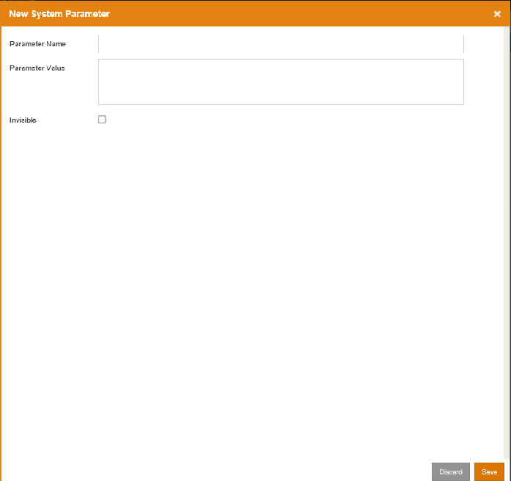

The description of each field is listed below:

|  |  |
| --- | --- |
| 欄位 | 說明 |
| Parameter Name | Unique name for the system parameter |
| Parameter Value | Information for the system parameter |
| Invisible |  |

### 1.1.2 Update System Parameter

To update system parameter, select the parameter and click the  button or double click the parameter to bring up the following update parameter screen:

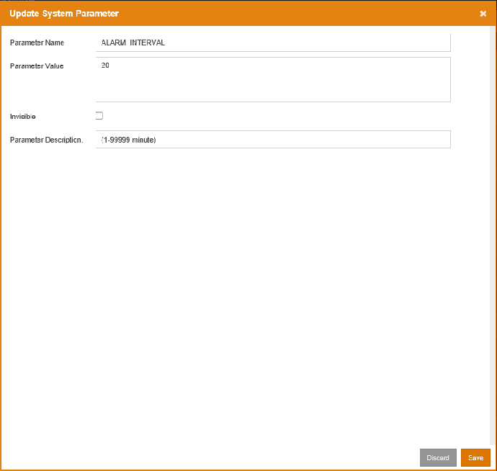

Once the modification is made, click the  button to save the changes. 按一下  鈕離開畫面而不去儲存變更。

### Delete System Parameter

To delete a parameter, select the parameter and click the  button. A confirmation message will prompt the user to confirm the deletion of the parameter as below:

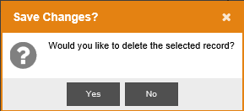

Click  button to delete the parameter or click  button to cancel the deletion.

### Send Testing Email

To check whether the SMTP settings are correct, press the  button to send a testing email to the Technician user.

# Supervisor

## OCR Station Management

To define OCR server, click OCR Station Management on the navigation bar, and the following screen will show. At the OCR Station Setting tab, Technician can define OCR Station ID, IP address, Port, and interval time, etc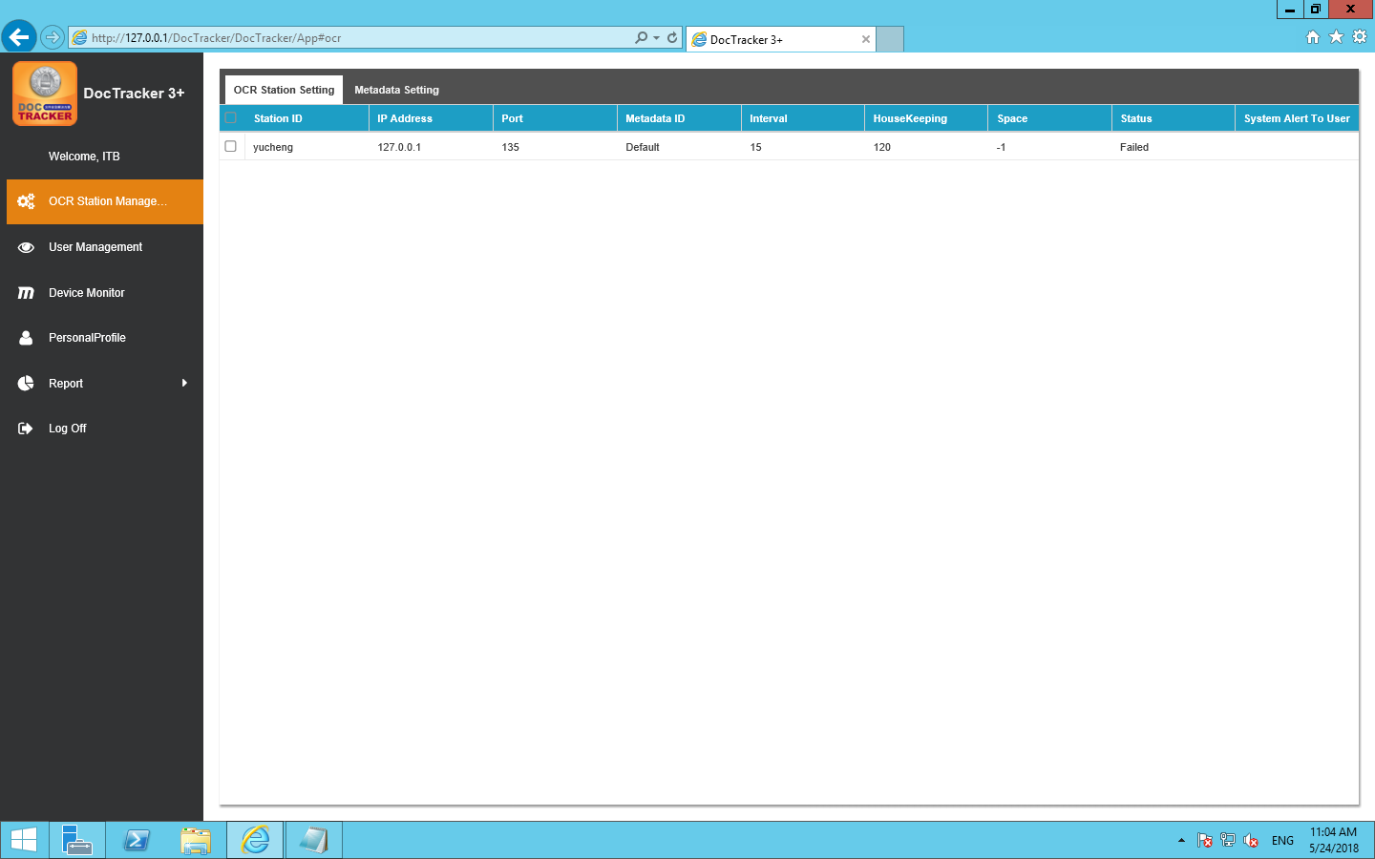

The functions of each field are listed below:

|  |  |
| --- | --- |
| 欄位 / 按鈕 | 說明 / 功能 |
| Station ID | OCR server unique name |
| IP 位址 | OCR 伺服器的IP 位址 |
| Port | OCR server platform’s connection port |
| Metadata ID | Metadata to be used in the OCR server |
| Interval | The interval time (in minute) to monitor the specific folder for OCR server. |
| HouseKeeping | The time period (in month) to keep the information in the OCR server |
| 可用空間 | Available space (in GB) in OCR server |
| 狀態 | The connection status between the DocTracker server and the OCR server |
| System Alert to User | If OCR server is disconnected, specified DocTracker user will receive an email notification |

## 用戶管理

Once login with Supervisor role, DocTracker main page will show User Account Summary as below:

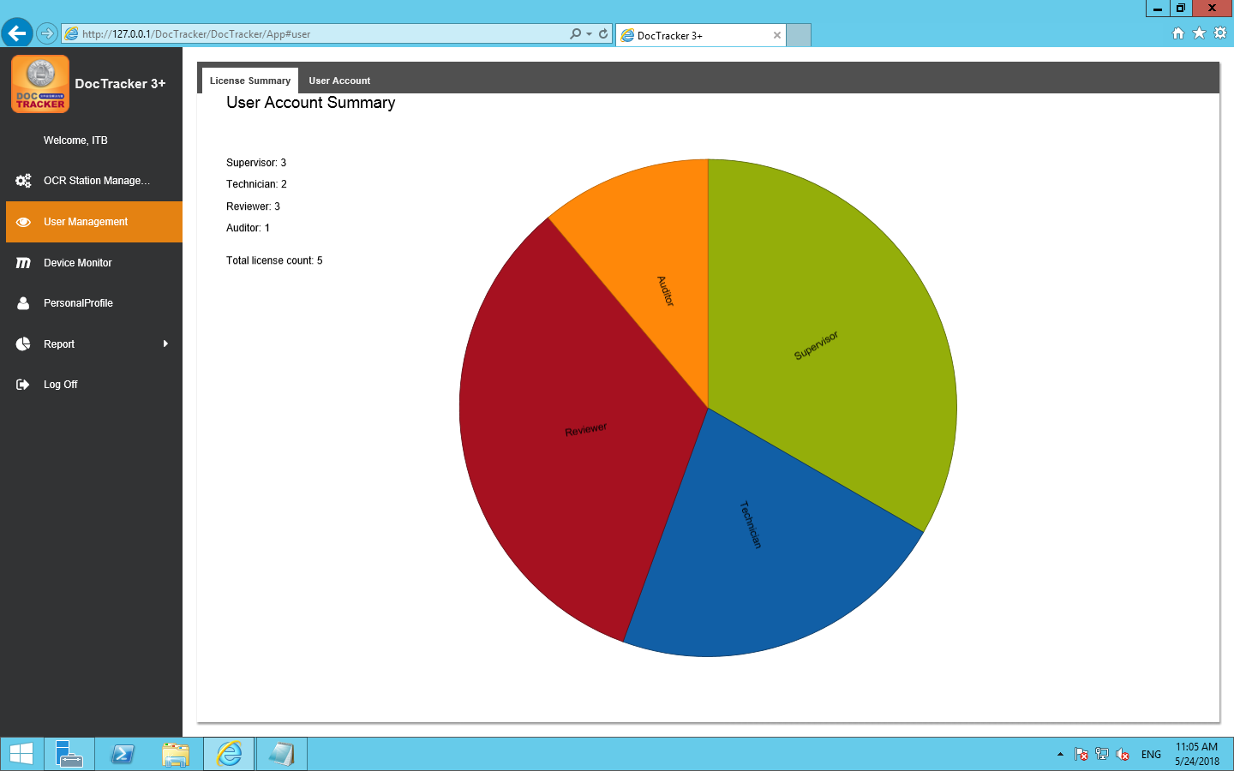

### New User

Before setting up and starting to use the DocTracker, you need to create user accounts for different roles. The Admin role can create accounts for the (Supervisor, Technician) role, and the Supervisor role can create accounts for the (Auditor, Reviewer) role. To add a new user, go to the  tab, click the  button, and the following screen will pop up:

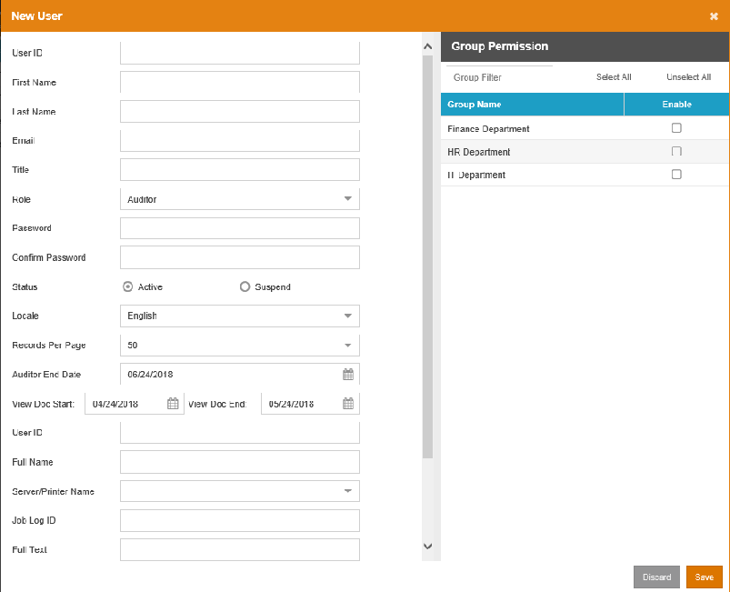

下面列出了每個欄位和按鈕的功能：

|  |  |
| --- | --- |
| 欄位 / 按鈕 | 說明 / 功能 |
| 用戶帳號 | 使用者唯一的登錄ID。 |
| 用戶名 | 用戶的名字。 |
| 用戶姓 | 用戶的姓氏 |
| 電子郵件 | 用戶的電子郵件地址 |
| 職稱 | 用戶的職稱。可留空。 |
| 角色 | Technician角色的帳號有權限去設定系統。Supervisor角色的帳號有權限去建立 Reviewer 和 Auditor。 |
| 密碼 | 使用者的登入密碼 |
| 確定密碼 | 重新輸入使用者的登入密碼 |
| 狀態 | 使用者的狀態。“Active” enables the user to logon to the system. “Suspend” disables the user to access the system. |
| 語言 | 使用者介面呈現的語言。可設定為「English」（英文）、「Simplified Chinese」（簡體中文）、「Traditional Chinese」（繁體中文）。 |
| 每頁紀錄 | 每頁顯示的記錄數。 數值的範圍從10到60。 |
|  | 按此按鈕離開此頁面而不添加使用者帳號。 |
|  | 按下此按鈕可透過已輸入的使用者資訊來創建使用者帳號。 |

### User Info Update

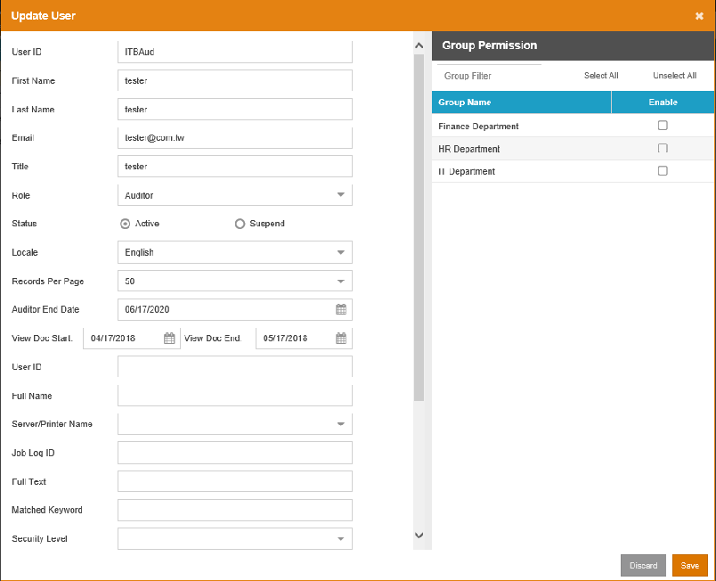

### Delete User Account

1. 如果要進行使用者帳號刪除, 勾選要刪除的使用者帳號後按下 鈕。A confirmation message will prompt the user to confirm the deletion of the user as below 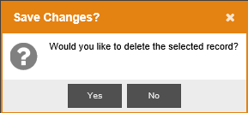
2. 按一下  後刪除使用者，又或按一下  取消刪除動作。

### 重置密碼 重置

要為特定的使用者重置密碼，先選定要重置的使用者帳號，然後按一下 按鈕，帶出接下來的[重設用戶密碼]畫面：

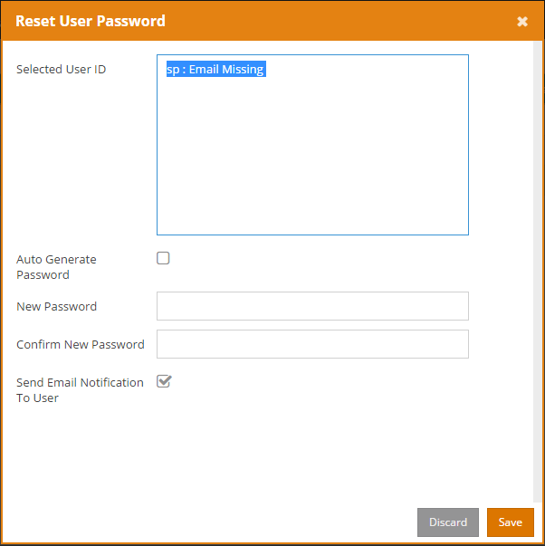

按一下  鈕重置。按一下  鈕離開畫面而不去重置密碼。

下表介紹了[重置用戶密碼]畫面中的文字：

|  |  |
| --- | --- |
| 欄位 | 說明 |
| 已選用戶帳號 | 顯示所選的用戶帳號，以及該用戶是否有設定電子郵件地址 |
| 自動產生密碼 | 自動生成密碼，並通過電子郵件發送給此用戶。 |
| 新密碼 | 為此用戶定製一個密碼。 |
| 確認新密碼 | 再一次輸入剛才定製的密碼。 |
| 電子郵件通知用戶 | 在為該用戶定製過密碼後，將密碼透過電郵向用戶發放。 |

### 檢視部門 (except MFP)

查看訪問映射權限中的用戶映射, 或者查看AD OU映射中的AD / OU權限, 按下 按鈕去瀏覽群組和群組底下的使用者.

## Device Monitor

The Device Monitor displays the number of printed documents, the number of copied documents, the number of scanned documents, and the number of faxed documents.

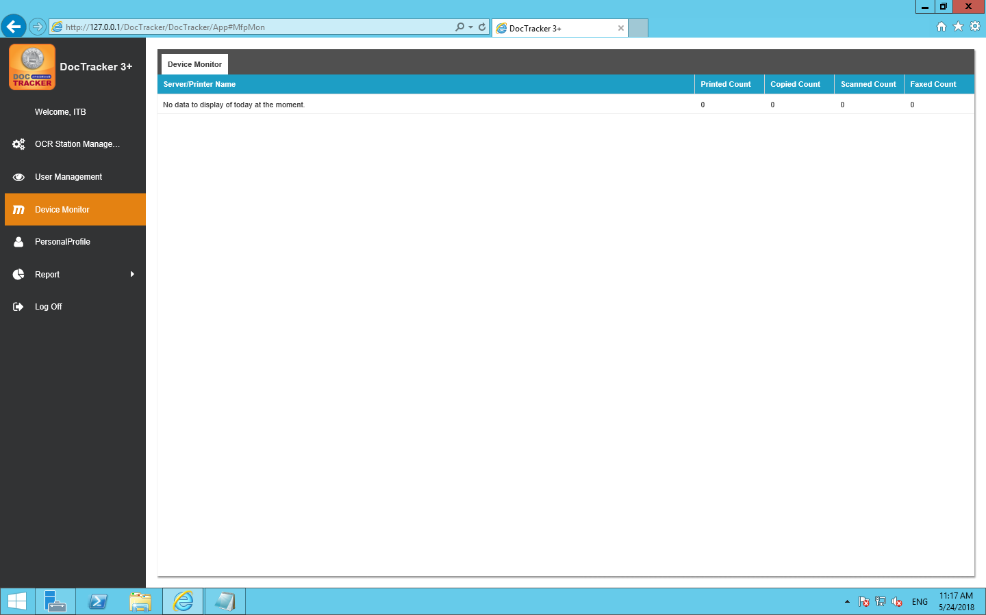

## 用戶個人資料

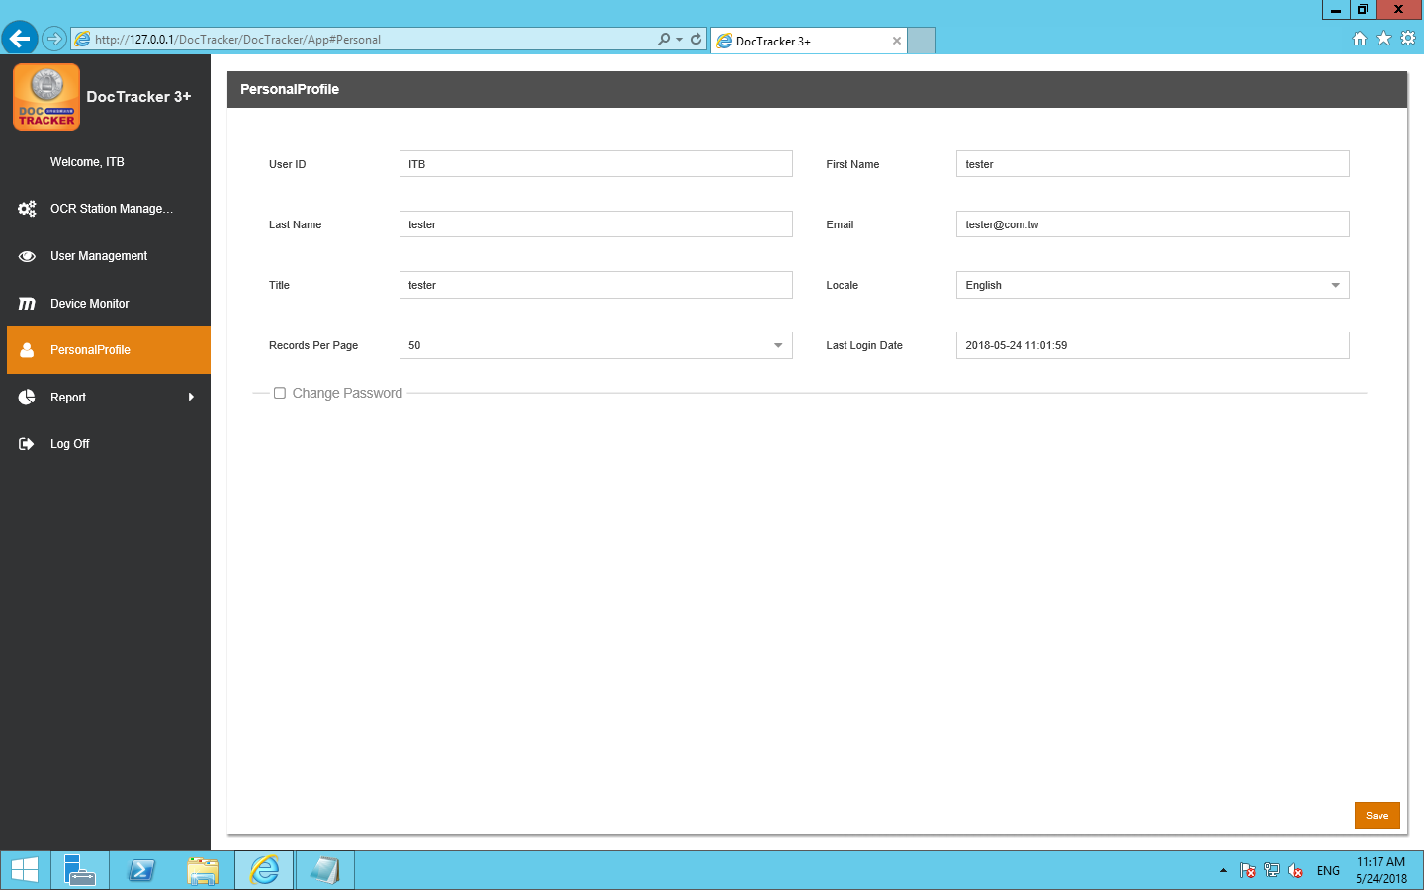

It shows user information about [User ID] [First Name] [Last Name] [Email] [Title] [Locale][Records Per Page][Last Login Date], language can be adjusted by [Locale].

In addition to the [User ID] can not be changed, other information can be changed

Press after change and a following screen will pop up:



The new setting will take effect after the next login.

## 報告

### 報告

To create different types of system report, click Report button under the Report in the navigation bar, and the following screen will pop up: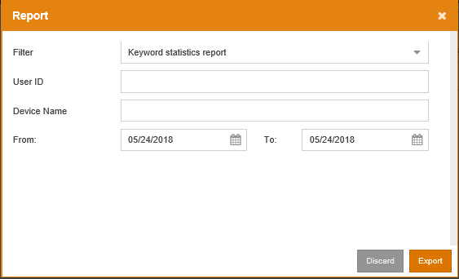

### Audit Trail

DocTracker 記錄每個文件的活動。沒有一個 DocTracker 用戶可以修改或刪除 Audit Trail 中的任何項目。要查看審計追蹤，請單擊導航列中「報告」下的「審計追踪」，之後將會顯示以下畫面： 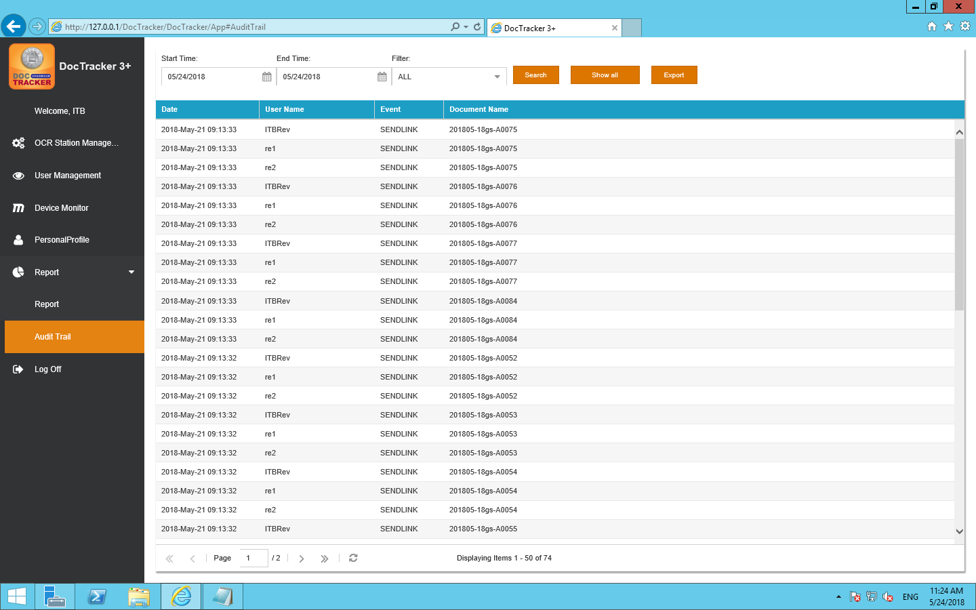

|  |  |
| --- | --- |
| 欄位 / 按鈕 | 說明 / 功能 |
| 開始 時間 | 要搜尋的開始日期 |
| 結束 時間 | 要搜尋的結束日期 |
| 過濾 | 顯示審計追踪的特定事件，包括「全部」、「瀏覽」、「刪除」和「發送連結」 |
|  | 按一下這個按鈕去使用所選條件執行搜索 |
|  | 按一下這個按鈕可顯示系統中發生的所有活動 |
|  | 按一下這個按鈕去把審計追踪匯出成為excel檔案 |

# Auitor

## Dashboard

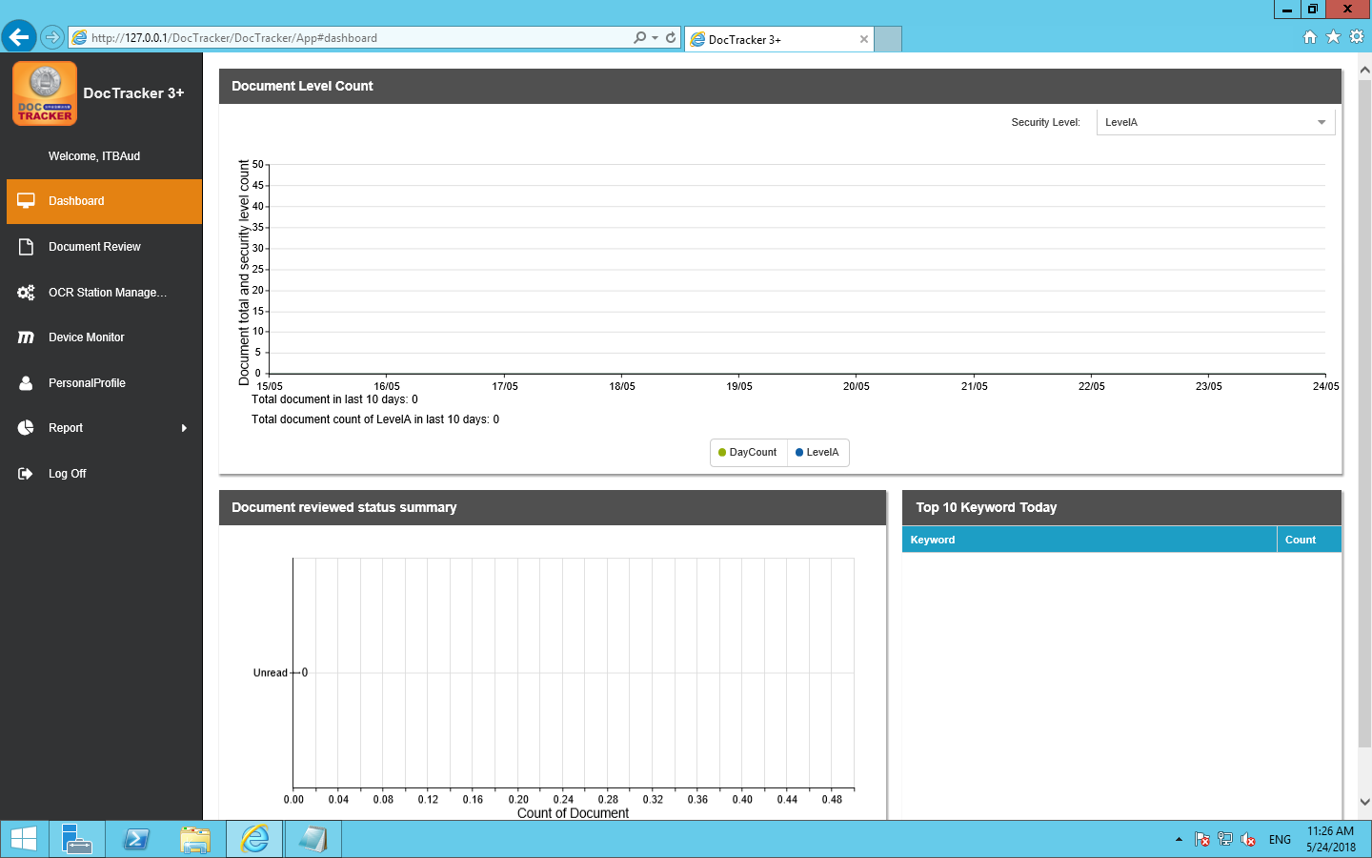

### View Settings

Set up a drop-down menu on the screen 

Set different security levels for viewing, Viewable items:

1.Document total security level count

2.Document reviewed status summary

3.Top 10 Keyword Today

## OCR Station Management

To define OCR server, click OCR Station Management on the navigation bar, and the following screen will show. At the OCR Station Setting tab, Technician can define OCR Station ID, IP address, Port, and interval time, etc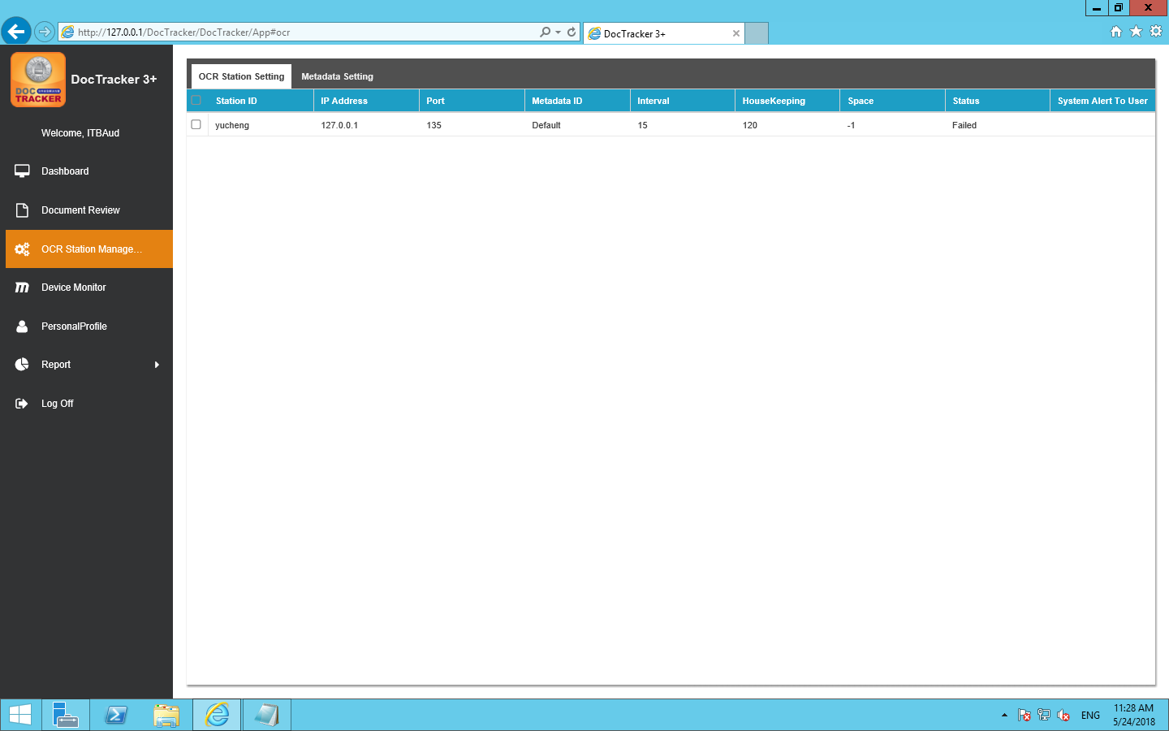

The description of each fields are listed below:

|  |  |
| --- | --- |
| 欄位 / 按鈕 | 說明 / 功能 |
| Station ID | OCR server unique name |
| IP 位址 | OCR 伺服器的IP 位址 |
| Port | OCR server platform’s connection port |
| Metadata ID | Metadata to be used in the OCR server |
| Interval | The interval time (in minute) to monitor the specific folder for OCR server. |
| HouseKeeping | The time period (in month) to keep the information in the OCR server |
| 可用空間 | Available space (in GB) in OCR server |
| 狀態 | The connection status between the DocTracker server and the OCR server |
| System Alert to User | If OCR server is disconnected, specified DocTracker user will receive an email notification |

## Document Review

DocTracker supports dual authentication when a user views a document. Before viewing a document, authentication of two users is required. After clicking Document Review in the navigation bar, documents that are created on that day will be listed as below. Users can select any dates to view the documents of that day. 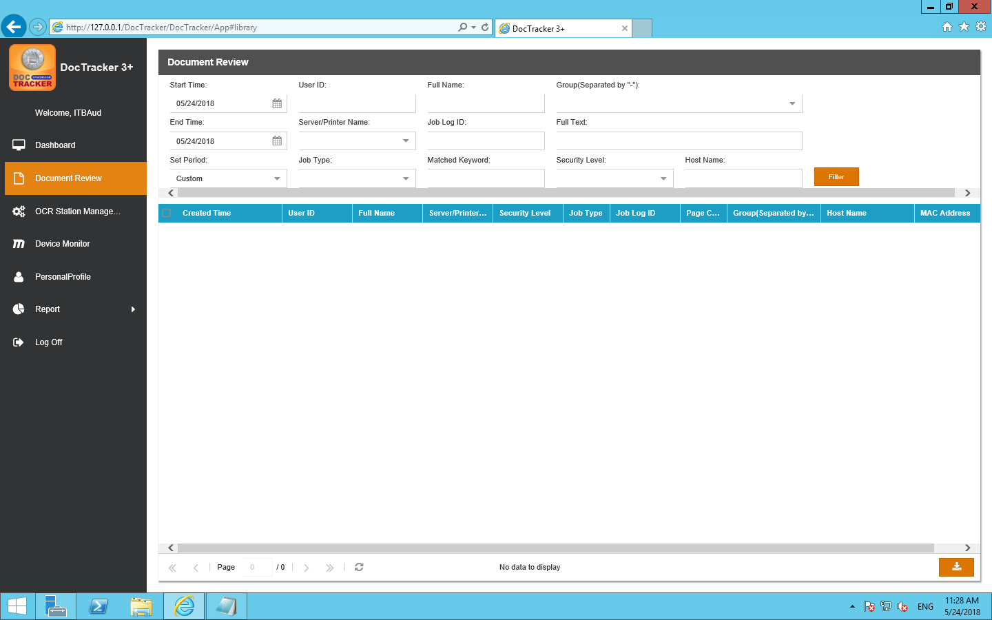

## Device Monitor

The Device Monitor displays the number of printed documents ,the numbers of copied document ,the number of scanned documents ,and the numbers of faxed documents.

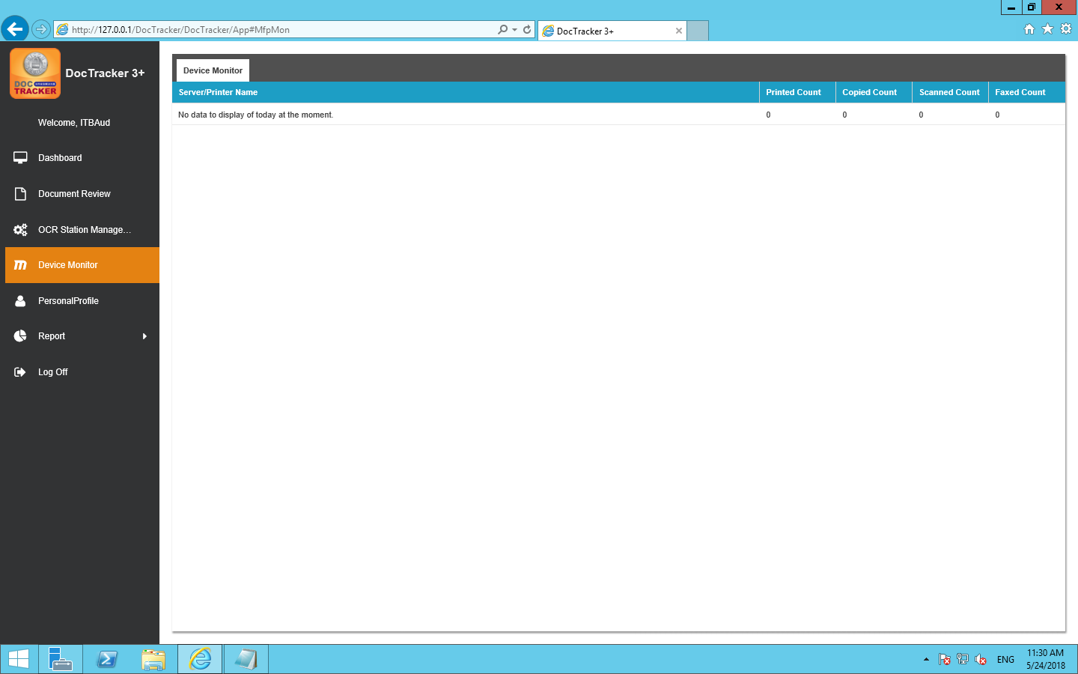

## 使用者個人資料

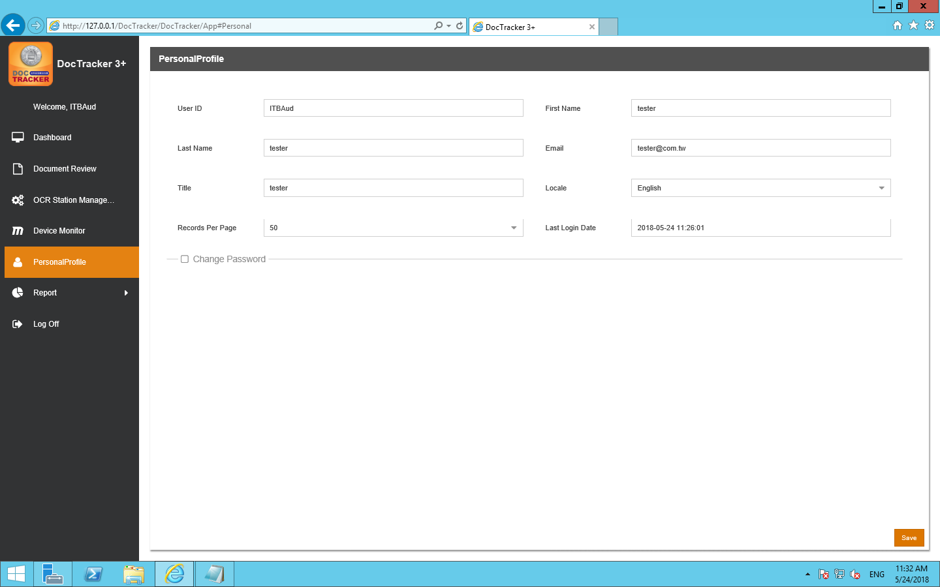

It shows user information about [User ID] [First Name] [Last Name] [Email] [Title] [Locale][Records Per Page][Last Login Date], language can be adjusted by [Locale].

In addition to the [User ID] can not be changed, other information can be changed

Press after change and a following message appears

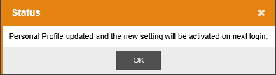

即新的設定會在下次登入後生效.

## 報告

### 報告

To create different types of system report, click Report button under the Report in the navigation bar, and the following screen will pop up: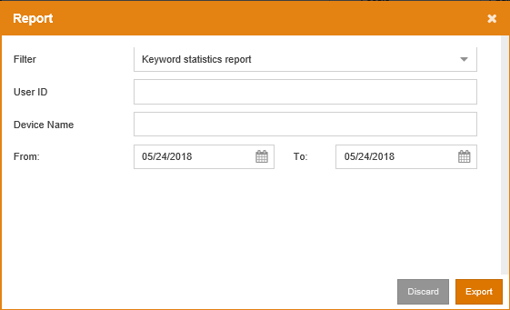

### Audit Trail

DocTracker 記錄每個文件的活動。沒有一個 DocTracker 用戶可以修改或刪除 Audit Trail 中的任何項目。要查看審計追蹤，請單擊導航列中「報告」下的「審計追踪」，之後將會顯示以下畫面： 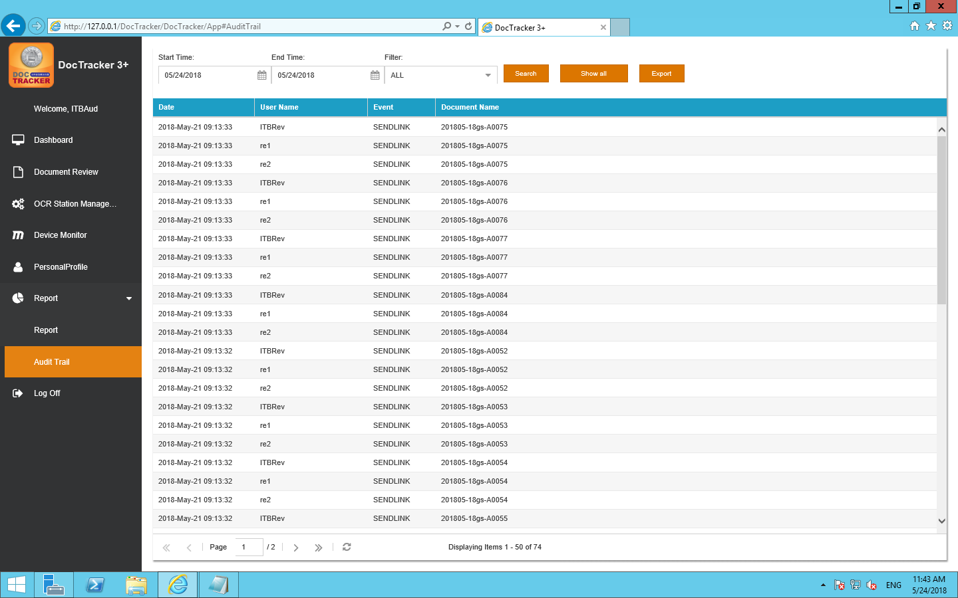

|  |  |
| --- | --- |
| 欄位 / 按鈕 | 說明 / 功能 |
| 開始 時間 | 要搜尋的開始日期 |
| 結束 時間 | 要搜尋的結束日期 |
| 過濾 | 顯示審計追踪的特定事件，包括「全部」、「瀏覽」、「刪除」和「發送連結」 |
|  | 按一下這個按鈕去使用所選條件執行搜索 |
|  | 按一下這個按鈕可顯示系統中發生的所有活動 |
|  | 按一下這個按鈕去把審計追踪匯出成為excel檔案 |

# Reviewer

## Dash Board

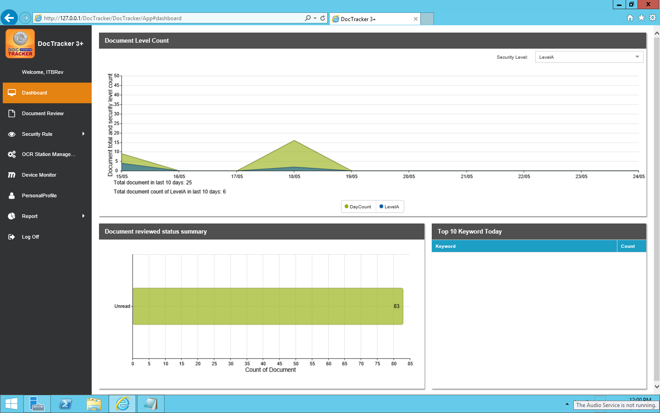

### View Setting

Set up a drop-down menu on the screen 

Set different security levels for viewing, Viewable items:

1.Document total security level count

2.Document reviewed status summary

3.Top 10 Keyword Today

## Document Review

DocTracker supports dual authentication when a user views a document. Before viewing a document, authentication of two users is required. After clicking Document Review in the navigation bar, documents that are created on that day will be listed as below. Users can select any dates to view the documents of that day.

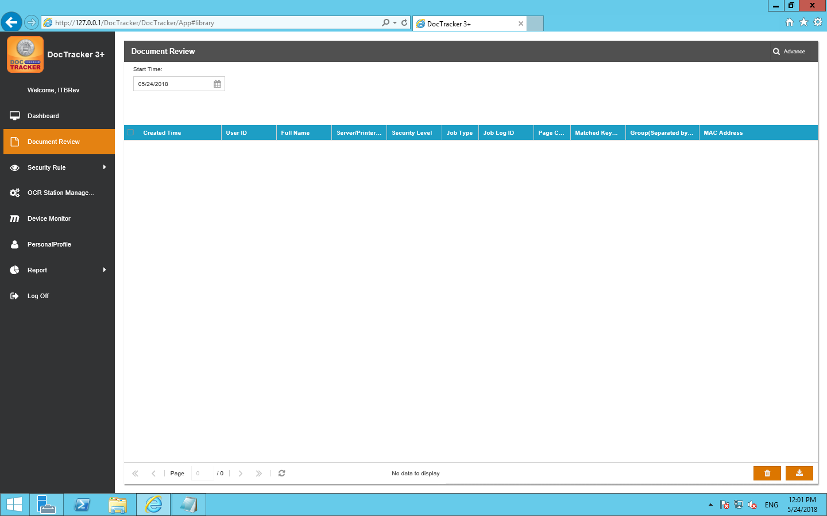

## Security Rule (Reviewer Only)

When DocTracker recognizes the sensitive keywords in the saved document, an email notification by default will be sent to the reviewer of that group.

### KeyWords

Click the Keyword under Security Rules in the navigation bar will show the following screen:

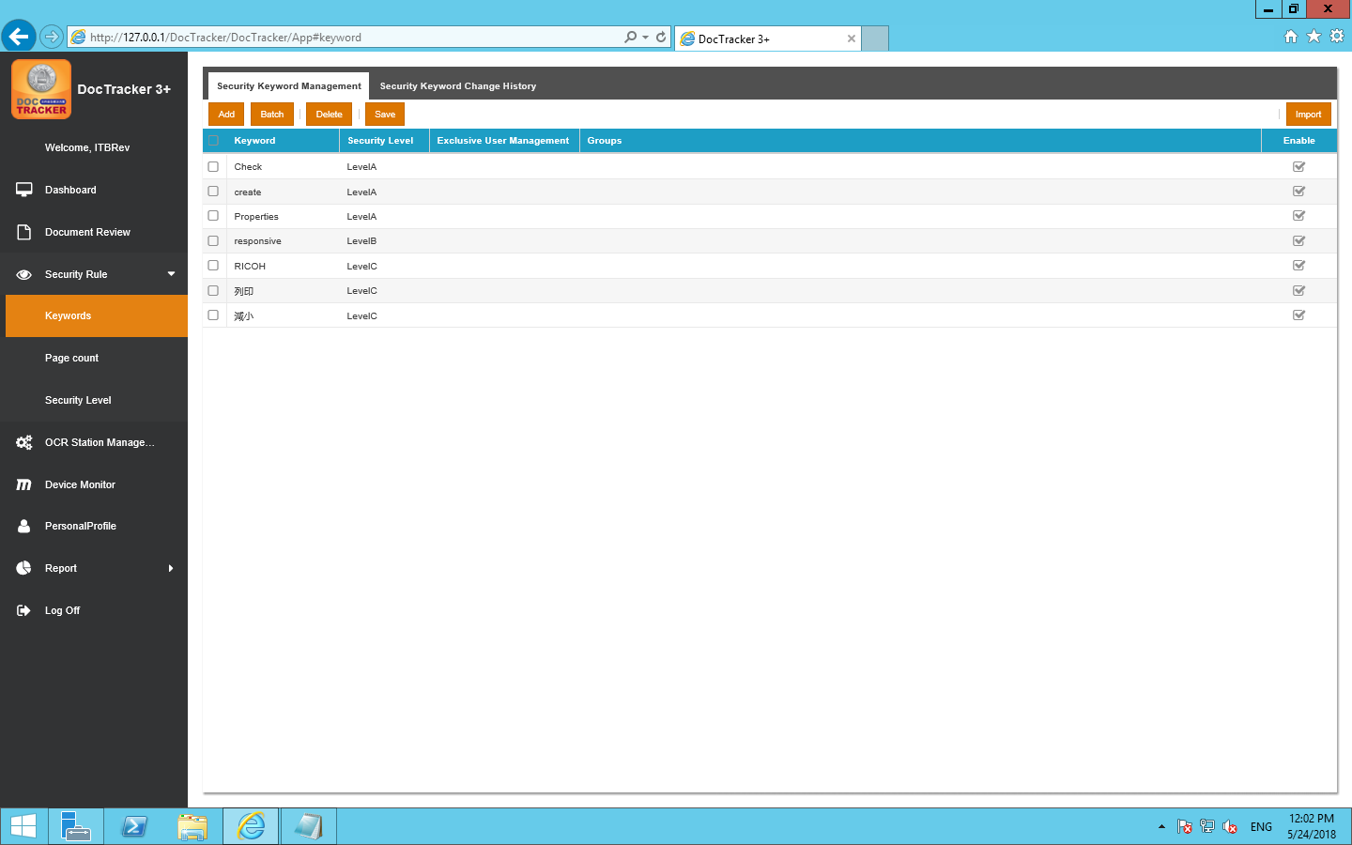

### Add New Keyword

To add a new keyword, click the button and a new entry will be created.

The description of each field are listed below:

|  |  |
| --- | --- |
| 欄位 | 說明 |
| Keyword | Sensitive keyword of any languages.  Click to modify the keyword.。 |
| Security Level | Security Level of the sensitive keyword.  Default Levels are A,B,and C. |
| Exclusive User Management | The document that is uploaded by the exclusive user will be ignored |
| Groups | Only the document that is uploaded by the defined group will be recognize Double click to modify the groups. |
| Enable | Check this box to activate the keyword. |

### Batch Update

To batch update the keyword entries. Select desired entries to update and click

the button. and the following screen will pop up:

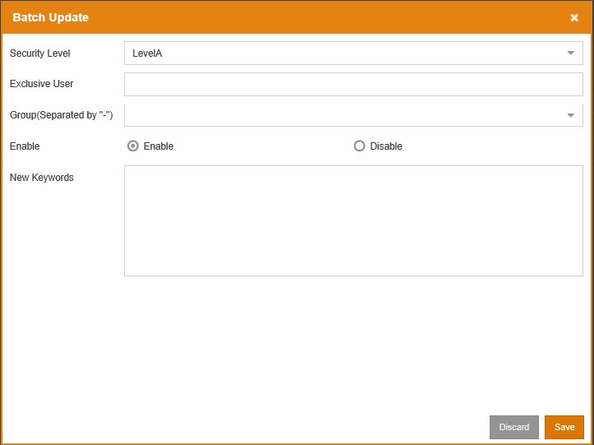

Once the modification is made, click the  to save the changes for all selected entries. Click the  to exit the screen without saving

### Delete Keyword

To delete keywords, select one or more entries and click the  button。

### Import Keyword

Keywords can be imported from a CSV file. To import, click the  button.

Browse the CSV file and click the  button.

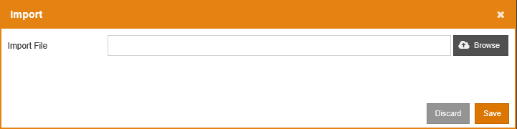

A confirmation message will pop up as below. Click  to import the keyword, or click  to cancel.

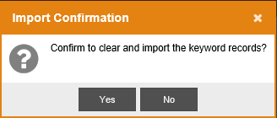

### Security Keyword Change History

To view the keyword history, click the  tab, and the following screen will be shown: 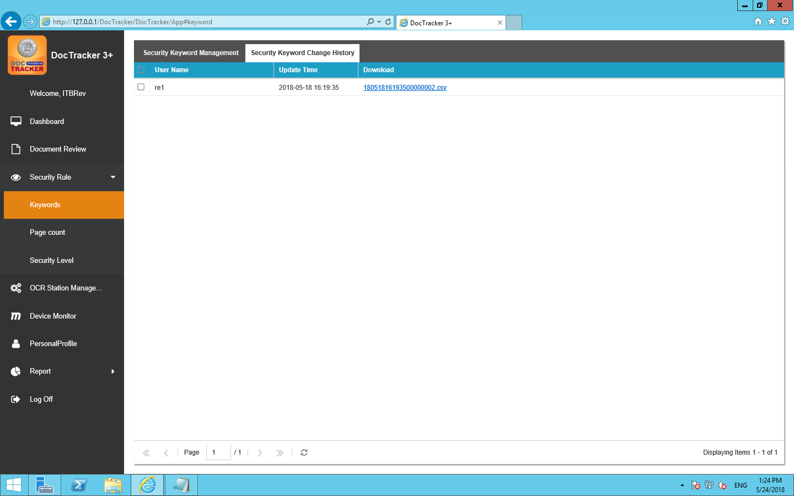

The descriptions of each field are listed below:

|  |  |
| --- | --- |
| 欄位 | 說明 |
| 使用者名稱 | The user who update the keyword |
| Update Time | The date and the time of the update |
| Dawnloud | Double click to download the CSV file of the keyword to your workstation |

**3.1.2數量(值)(功能未知)**

### Security Level

Sensitive keyword by default has three levels: A, B, and C. If a Level A sensitive keyword is found, an email notification will be sent immediately. If a Level B sensitive keyword is found, an email notification will be sent according to the defined time in the system setting. If a Level C sensitive keyword is found, no email notification will be sent. The default security levels cannot be modified.

Click the Security Level under Security Rules in the navigation bar will show the following screen: 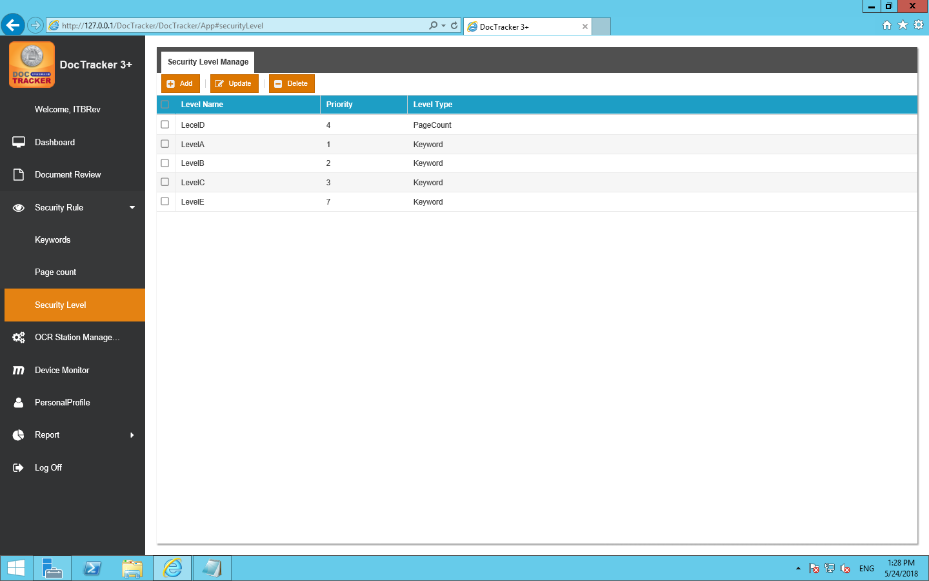

### Add New Security Level

To add a new security level, click the  button and the following screen will pop up:

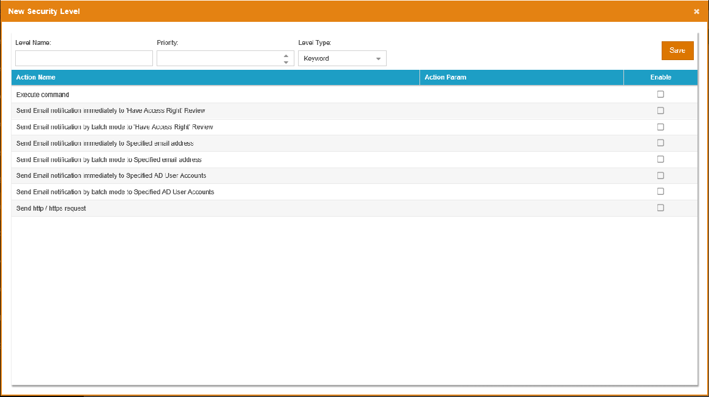

下面列出了每個欄位和按鈕的功能：

|  |  |
| --- | --- |
| 欄位 / 按鈕 | 說明 / 功能 |
| Level Name | The unique name of the security level |
| Priority | The sequence of the security level for checking |
| Level Type | Only “Keyword” is useable currently |
|  | Press this button to create the security level |

### Update Security Level

To update a security level, select the security level and click the  button and the following screen will pop up: 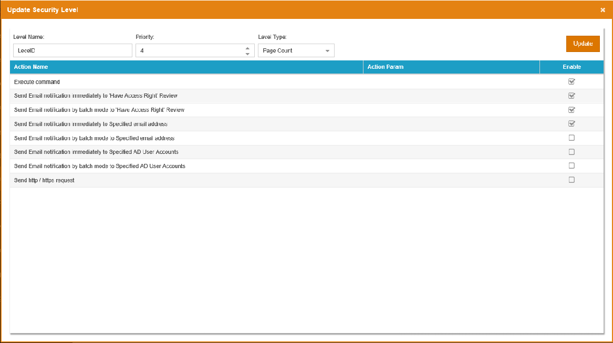

Once the modification is made, click the  button to save the changes.

### Delete Security Level

To delete security levels, select one or more entries and click the  button. A confirmation message will prompt the user to confirm the deletion of the security level as below.

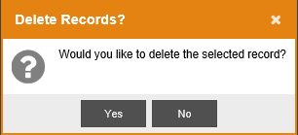

Click the  button to delete the security level or click the  button to cancel the deletion.

## OCR Station Management

To define OCR server, click OCR Station Management on the navigation bar, and the following screen will show. At the OCR Station Setting tab, Technician can define OCR Station ID, IP address, Port, and interval time, etc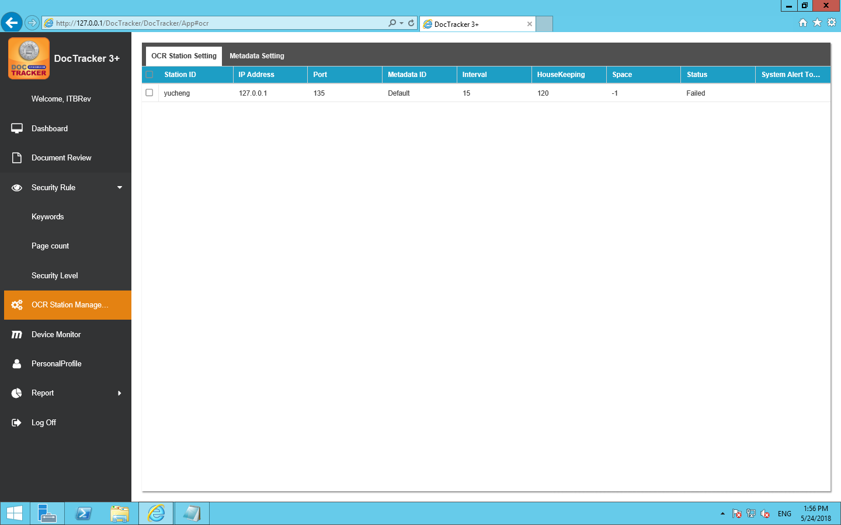

The description of each field are listed velow:

|  |  |
| --- | --- |
| 欄位 / 按鈕 | 說明 / 功能 |
| Station ID | OCR server unique name |
| IP 位址 | OCR 伺服器的IP 位址 |
| Port | OCR server platform’s connection port |
| Metadata ID | Metadata to be used in the OCR server |
| Interval | The interval time (in minute) to monitor the specific folder for OCR server. |
| HouseKeeping | The time period (in month) to keep the information in the OCR server |
| 可用空間 | Available space (in GB) in OCR server |
| 狀態 | The connection status between the DocTracker server and the OCR server |
| System Alert to User | If OCR server is disconnected, specified DocTracker user will receive an email notification |

## Device Monitor

The Device Monitor displays the number of printed documents, the number of copied documents, the number of scanned documents, and the number of faxed documents.

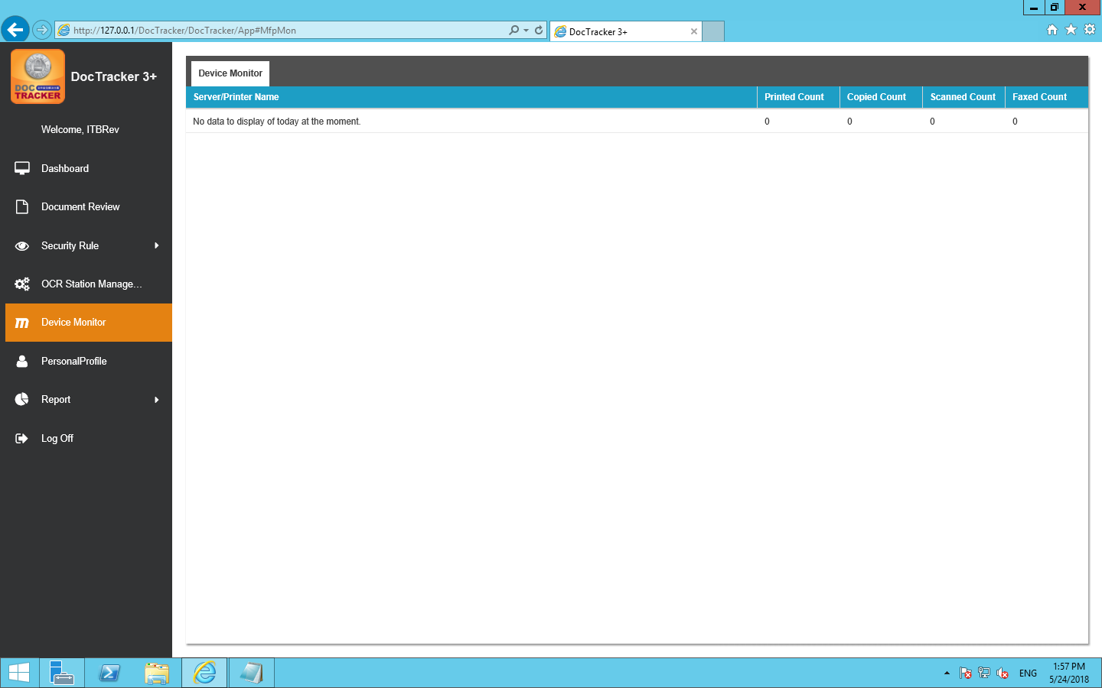

## 使用者個人資料

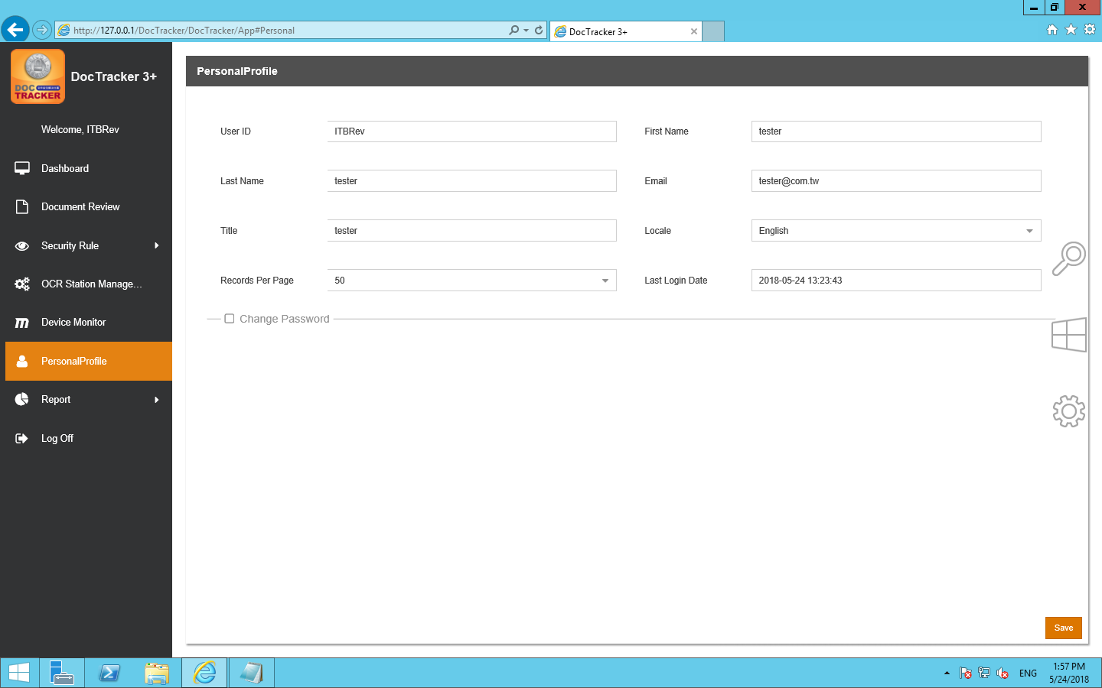

It shows user information about [User ID] [First Name] [Last Name] [Email] [Title] [Locale][Records Per Page][Last Login Date], language can be adjusted by [Locale].

In addition to the [User ID] can not be changed, other information can be changed

Press after change and a following message appears

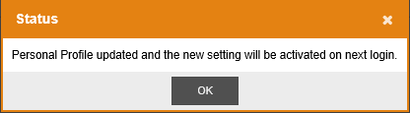

The new settings will be activated after the next login..

## 報告

### 報告

要建立不同類型的系統報告，請在導航列中的報告按鈕下點擊報告按鈕，之後會顯示以下畫面： 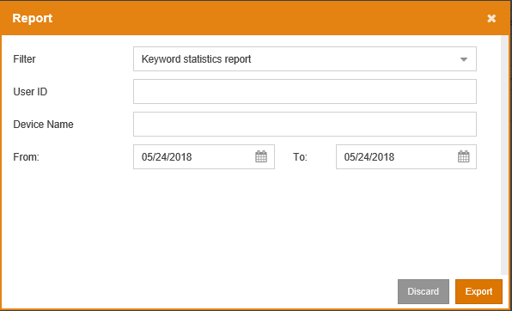

### 審查紀錄

DocTracker 記錄每個文件的活動。沒有一個 DocTracker 用戶可以修改或刪除 Audit Trail 中的任何項目。要查看審計追蹤，請單擊導航列中「報告」下的「審計追踪」，之後將會顯示以下畫面： 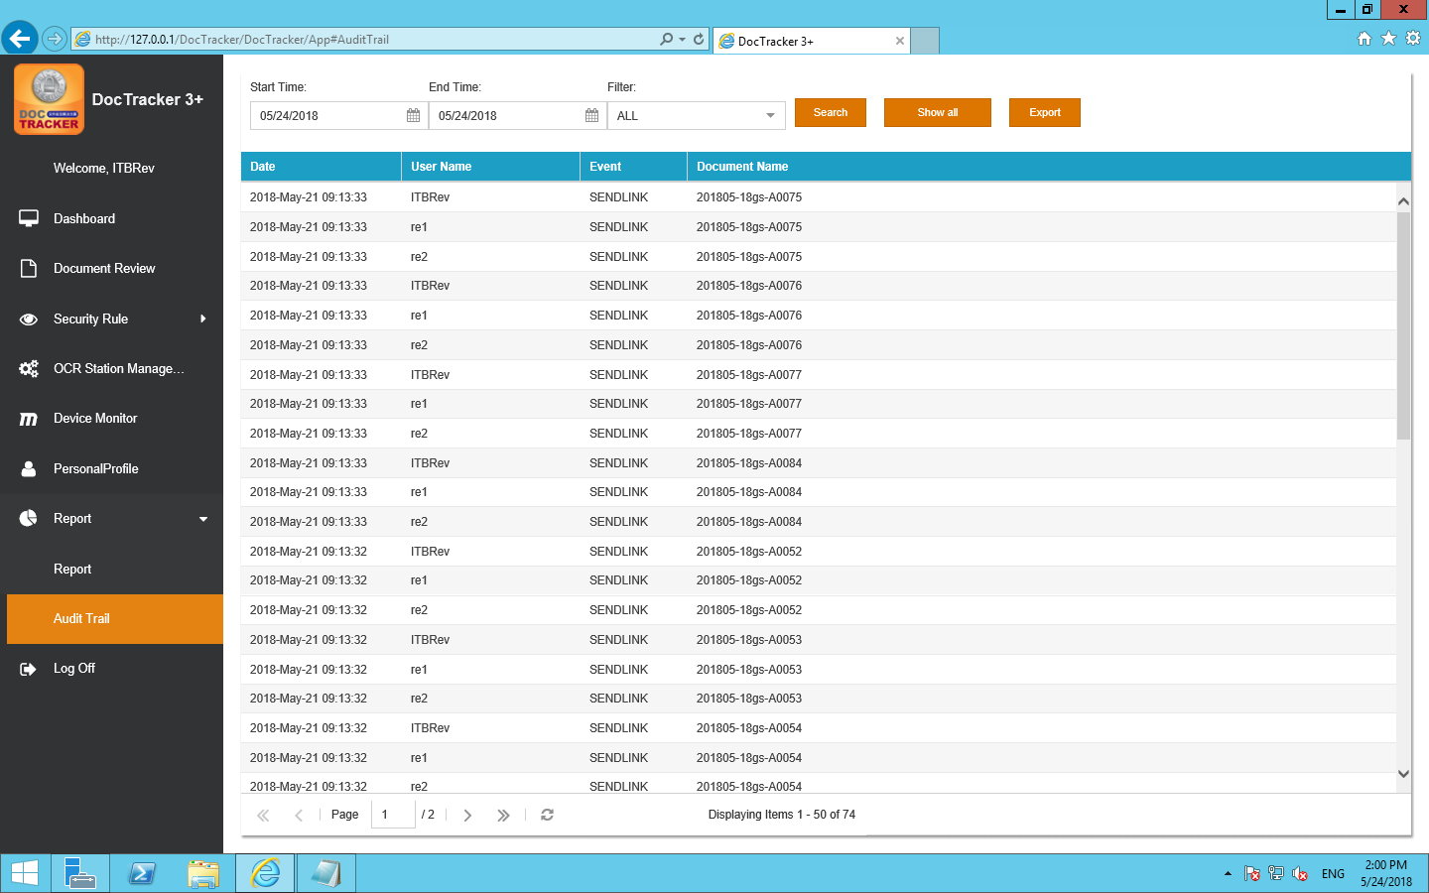

下面列出了每個欄位和按鈕的功能：

|  |  |
| --- | --- |
| 欄位 / 按鈕 | 說明 / 功能 |
| 開始 時間 | 要搜尋的開始日期 |
| 結束 時間 | 要搜尋的結束日期 |
| 過濾 | 顯示審計追踪的特定事件，包括「全部」、「瀏覽」、「刪除」和「發送連結」 |
|  | 按一下這個按鈕去使用所選條件執行搜索 |
|  | 按一下這個按鈕可顯示系統中發生的所有活動 |
|  | 按一下這個按鈕去把審計追踪匯出成為excel檔案 |